EXPERIMENT-8
NAME: ASHWIN D ROLL NO:240701059
USER INTERFACE DESIGN

Create storyboards to represent the user flow for your application using Balsamiq here this software is used to show your application flow. which you can design the low fidelity prototype using the blasmiq normally the story board should create with comic scene. but here in this software you need to create the usage flow of the application in design in one screen.
Step by Step user Journey:
- App Launch (The First Impression):
The journey begins with a clean splash screen displaying the TaskMate name. This is a simple entry point that allows the app to load while establishing the brand identity for the user.
- Login Page (The Security Gate):
Next, the user reaches the Welcome screen. Here, they can securely log in using their email and password. I’ve included "Forgot Password" and "Sign Up" links to ensure the user doesn't get stuck if they forget their details or are new to the app.
- Dashboard Page (The Central Hub):
Once logged in, the user lands on the Dashboard. This is where they can see their current list of tasks with checkboxes to mark them as done. I added an "Edit" button for existing tasks and a prominent Add Task button at the bottom to guide the user toward the next action.
- Add Task Page (The Creation Step):
When the user clicks "Add Task," they are taken to a clean form. I designed this with two simple input fields: one for the Task title and one for a Description. This keeps the process of adding a new item quick and distraction-free.
- Added Successfully Page (The Feedback):
After clicking "Add," the final screen provides clear Success Feedback with a large green checkmark. This confirms the action was successful. From here, the user has two clear choices: "View All Tasks" to go back to the dashboard or "Add another Task" to keep working.
Low-Fidelity Storyboard and Wireframe Design:
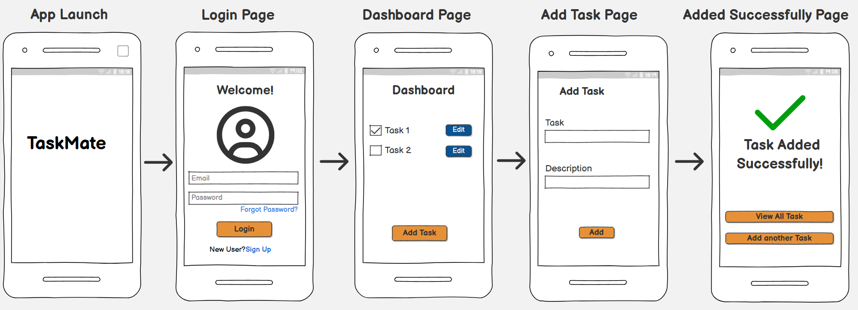

Wireframe link:
https://balsamiq.cloud/sdfsmcd/pculfda

